Regard’s Pride Access Guide

BM Box Regard, London WC1N 3XX.
secretary@regard.org.uk / www.regard.org.uk

It is normal to be disabled, just as it is normal to be Lesbian, Gay, Bisexual or Trans (LGBT) — around one in five people in the UK are disabled, although they may or may not identify with this label. As with LGBT people, it is the artificial barriers society creates that prevent disabled and older people from participating fully in society. The impact of homophobia and transphobia on LGBT people’s long-term physical and mental health, together with the higher incidence of HIV, mean that disabled people form an even larger part of the LGBT community than they do of the population as a whole. It is therefore particularly important that we organize community events in a way that makes them accessible and enjoyable for all.

PRIDE is for …

Publicity, which is vital, both before and during the event. Disabled people will often need to make detailed plans weeks or even months in advance in order to be able to attend Pride, so it is essential that publicity about access arrangements goes out at the same time as the rest of the Pride publicity. All Pride publicity materials need to be written and designed as accessibly as possible and to be available in a variety of formats — in large as well as standard print, electronically and so on. Remember that it is best to make your ‘main’ materials accessible to as wide a range of people as possible, though, rather than leaving everyone over the age of 40 to ask for your large print materials! And don’t assume that everyone knows you have a website, let alone that they can use it, and only put the access information there.

Parking for Blue Badge holders close to the end of the march route/
location of your rally or festival. Blue Badge parking is in great demand, and so additional parking always needs to be put into place for Pride. Many Blue Badge holders will need access to their vehicles during Pride itself and will also need to make a quick get-away if they feel unwell, so avoid shuttle bus arrangements apart from to transport people to the gathering point for the march, and keep parking as close by as possible. Accessible vehicles are often over-height for standard car parks, and many disabled people require access to the rear to load wheelchairs, so don’t simply assume that booking spaces in a local car park is adequate. And don’t forget to provide support at the parking place with unloading wheelchairs.

Providing wheelchairs and people to push them, both on the march and at the rally or festival afterwards. Many Blue Badge holders won’t possess their own wheelchairs but will be unable to walk the whole of the march route, let alone have the energy to stay on their feet afterwards. The majority of manual wheelchair users will also be unable to propel themselves for more than part of the day. People with other impairments may prefer to use a wheelchair on the march as well, due to the difficulties of negotiating what are often uneven road surfaces in a crowd. Manual wheelchairs can be booked via your local short-term wheelchair loan service, often for free. If you have a local Shopmobility scheme, you may also be able to borrow powered scooters for disabled Pride goers who can use these.

Providing a ‘safe space’ on the march and a viewing platform at the rally or festival afterwards. Many disabled and older Pride goers will need to march in a space where access stewards are available to prevent them from being crowded out or bumped into, where they can feel confident and therefore proud. Providing this ‘safe space’ at the front of the march also helps to ensure that the whole march moves at a pace that is suitable for everyone. Invite all older and disabled people’s organizations to march in this space, and don’t forget that it will need to be clearly signed at the gathering point in order to be effective.

Afterwards, providing a viewing platform at your rally or festival maintains a safe space for those who need it, as well as enabling people with mobility needs to sit down but still to see what is happening on the stage. Disabled and older people will obviously want to bring their partners, friends or families with them, so both safe places need to be large enough to accommodate this, and the viewing platform will need to include seating for them as well as for ambulant disabled people. Viewing platforms will need careful security planning and stewarding in order to prevent them from being abused, and will need volunteers to fetch drinks etc as moving through crowds will be impossible for many disabled and older people who may effectively get trapped on the platform. Don’t forget to provide shade and sunscreen too for the same reason.

Palantype facilities at your rally or festival. A palantypist provides real-time sub-titles on a big screen when people are performing and making speeches, widening access for everyone who is hard of hearing (including many older LGBT people). As with many access arrangements, both the palantypist and the big screen can be relatively easy to find sponsorship for, but need advance booking. Along with other forms of accessible information, having sub-titles makes it easier for people with English as an additional language to participate too, and is generally helpful for announcements.

Power points for charging wheelchairs. Batteries for power wheelchairs and scooters are expensive and are quickly past their best; attending Pride can therefore leave people without the power to get home. Providing charging points on viewing platforms enables power wheelchair and scooter users to top up their batteries while they are enjoying the rally or festival.

PRIDE is for …

Remembering that most disabled people will have less access to their care and support networks at the weekends, when Pride usually takes place. Many will also not be out to their carers and support workers, so cannot call on them for assistance. Just coming to Pride at all will be really challenging for the majority of disabled people; access arrangements that still make it more difficult for disabled Pride goers to participate than everyone else will be disabling rather than empowering.

Recruiting Access stewards and Access Support Assistants along with your other volunteers, including recruiting among disabled people themselves. All volunteers, from the Pride organizers downwards, should have Disability Equality Training (DET); this can usually be provided free via your local Regard group or disabled people’s organization. Access stewards and Access Support Assistants should have additional training so they are completely comfortable in their roles, and don’t offend the people they are trying to help through inappropriate actions or language.

Resources — there are a wide range of resources and training materials out there to help you to make your Pride fully accessible and inclusive; contact Regard if you need help in finding these (see the end of this Guide for contact details).

PRIDE is for ….

Information = power. Make sure that all of your Pride information is accessible, including your website. Provide as much information about the access arrangements as possible, and don’t assume that novice Pride goers will understand what you mean by a ‘safe space’ on the march or a ‘viewing platform’ at your rally or festival afterwards. Always provide contact details where people can find out even more detailed information (and respond swiftly), and ensure that people can phone, fax, email or write to you as their access needs dictate. On the day, make sure that programmes (in a range of formats including Braille) and other information are available in the safe space and viewing platform, and that stewards and access support volunteers also have copies to distribute.
Interpretation facilities. There is a large Deaf population within the LGBT community whose first language is British Sign Language (BSL) and who require interpretation to participate fully in Pride. This includes interpreting for stall-holders and for non-BSL-using Pride goers who Deaf people want to talk to as well as interpreting the events on stage at your rally or event. BSL interpretation for Pride is very demanding, so interpreters need to be properly qualified, and preferably from the LGBT community themselves so they understand the specific signs and expressions that Deaf LGBT people use. Interpreters are also in great demand, so early booking is essential. Again, it is often easy to find sponsorship for interpretation facilities.

PRIDE is for ….

Dial-a-ride buses or other accessible mini-buses, which can be used to transport disabled people from the Blue Badge parking and nearest railway stations to the gathering point.
On the march, mini-buses can be used to transport Pride goers who have found walking too difficult and who don’t want to use wheelchairs; afterwards they can be used to transport disabled Pride goers back to the station. As with all access arrangements, it is essential to provide full information about this service including a time-table. Ask your local transport providers about sponsorship to cover costs or provision in-kind, and don’t forget to provide support to help disabled and older people to use the service.

Disabled toilets, which are more properly called accessible toilets. These need to be provided at the gathering point for the march as well as at the rally or festival afterwards — it is worth checking with local businesses whether they have additional facilities that can be used by disabled and older Pride goers too. Stewards and access support assistants should also be given Radar keys that can be used to unlock a range of local authority and other accessible facilities. Toilets provided directly by Pride need properly stewarding — they should only be used by people who need them, but stewards need training so they don’t try to decide who ‘looks’ disabled or ask personal or inappropriate questions.

Dogs — Guide dogs, hearing dogs and every other kind of assistance dog. Many disabled people will only be able to participate in Pride if they bring their dog with them. Providing an area where dogs can have a drink and do their business safely, with a proper disposal bin, may be the only thing that makes this possible. (Put down a few squares of turf if your event takes place in a paved area, and don’t forget a shelter for dogs who have become over-heated as well as providing water and a bin.) All Pride goers with dogs will also appreciate this facility. If organized far enough in advance, many animal charities will welcome the opportunity to run this space and to promote their own work at the same time.
Disabled people, your biggest resource. Set up an access sub-committee to oversee the access arrangements, and ensure that all relevant groups and organizations of disabled people are invited to attend (don’t forget to offer them stalls at your event too). Always let LGBT disabled people themselves tell you what their needs are and how best to meet them.

PRIDE is for ….

Ensuring that the sound from your PA system is also being broadcast to hearing aid users. This is straightforward to arrange, even if you have to restrict this facility to the area around the viewing platform. Don’t forget to put up the hearing loop sign so that Pride goers with hearing aids know to switch their controls appropriately.

Equality. Disabled and older LGBT people should not have to beg and be grateful to be included at all, but should be enabled to participate in Pride on an equal basis. Many Prides will receive some public funding, which will oblige them to promote Disability Equality; all will be covered by disability discrimination laws. But equality should in any case be a fundamental part of the Pride experience. Making access integral to Pride planning is essential for creating a fully inclusive Pride.

Finally, don’t insist that Pride-goers pre-register to use parking or any other access facilities — quite apart from the impossibility of ensuring that disabled people know they are required to do this and the injustice of requiring disabled people to give notice that they are coming when everyone else can just turn up on the day, many people don’t want to appear on a list of LGBT people for fear of being ‘outed’ at a future date. Disabled people also spend much of their lives being regimented, ‘organised’ and having to prove their disability and having their dignity and self-respect undermined as a result;
this should not be part of the Pride experience.

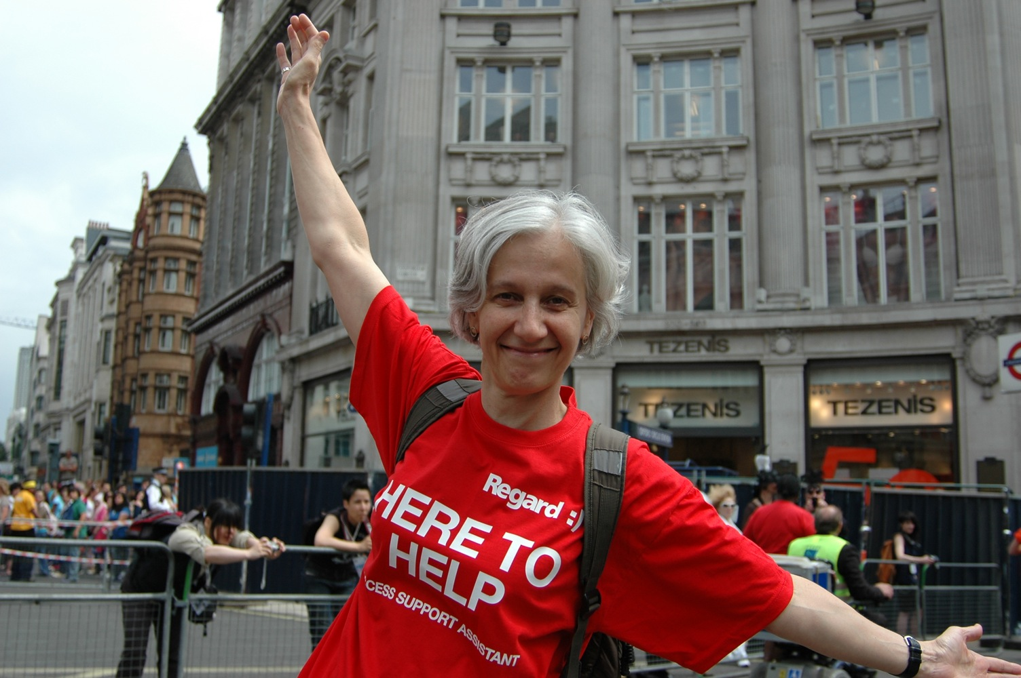
Regard is the national organization for LGBT disabled people and is a registered charity. Contact us by post at BM Box Regard, London WC1N 3XX, by email at secretary@regard.org.uk, or visit our website at www.regard.org.uk We welcome new members including non-disabled associate members and organizational supporters, and as an unfunded volunteer-run organization we also appreciate donations to support our work.

